Worlds Preview
Gary Wise
Well, it's that time of year. Through Pro Tours and Grand Prix, the world's finest have battled over the table, posturing and positioning themselves in the Player of the Year Race and a place in the most prestigious and important tournament of the year: Worlds.

Through Zak Dolan, Alexander Blumke, Tom Champheng, Jacub Slemr, Brian Selden, Kai Budde and Jon Finkel, Magic history has been told through its champions, and early August is that time of year when a new name gets added to the list of Magic World Champions. The question is who it will be.
There are any number of players who could conceivably win the World Championship, but this is a look at the top of that list. With over 200 qualified players, the title could go to anyone, but with this being the most gruelling tournament of the year, seeing eighteen rounds of Swiss followed by three rounds of Top 8 action, it's more likely than not that those players who are playing the best Magic going in to the tournament will emerge victorious. Here a look at some of those names:
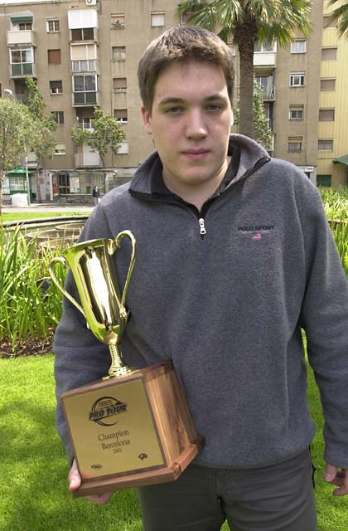
Kai Budde - How could this list start with any name but this one? The German Juggernaut has won two Pro Tours this year, one in Limited, one Standard, showing his prowess in both formats, and is likely the best player in the world right now. The frontrunner for the Player of the Year Race, Kai is leading the race by a whopping fourteen points, and one of the biggest stories in the tournament will be whether any of the players who are presently eating his dust can break through to win the tournament, potentially taking his second Player of the Year title away from him.
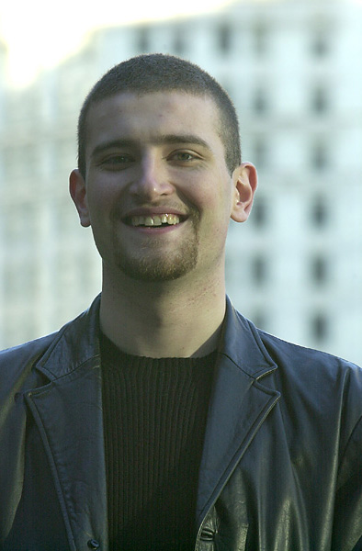Jon Finkel - The defending World Champion, Jon may have erased the questions about his motivation with his recent trip to Grand Prix-Taipei. Despite Antarctica's poor showing there, the fact he was willing to travel that distance for a Grand Prix suggests he's ready to get serious after what has, by only his standards, been a sub-par season, which has seen him make two Top 8s, but slowly fall out of the top ten on the Player of the Year Race. With the possibility of Jon falling off the Masters looming with a poor showing at Worlds, expect the Finkel of old to show himself.
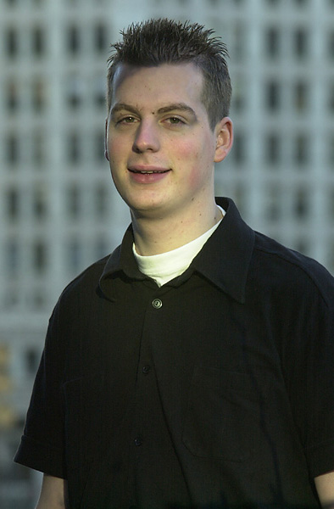
Kamiel Cornelissen - When Randy Buehler dubbed this wunderkind "the Dutch Dynamo," he wasn't too far off. Kamiel came into this season with one Pro Tour under his belt, but has accumulated more PT points this year than anyone on the planet aside from Kai. Kamiel has made two finals this year and it's scary to imagine how the race would look now if he'd won those matches. With his two finals coming in Limited and Constructed events, he's obviously capable of excelling in a tournament that features both formats. By the way, when Kamiel finished 29th in Tokyo, it was his worst PT performance ever. Ridiculous.
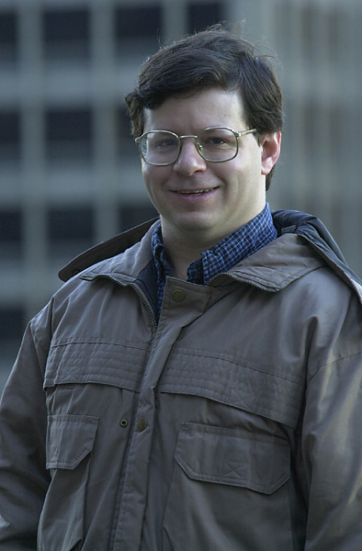
Mike Pustilnik - It seems like Mikey has been all but forgotten in the Player of the Year Race, but he's hanging in there, bolstered by his recent Top 4 finish at GP-Columbus. Mike made the Top 8 at the Constructed Pro Tour-Chicago before winning the Limited PT-LA, employing a draft style that would seem more suited to Apocalypse-inclusive draft than Invasion-Invasion-Planeshift, so he should be ready at World Championships. With Mike's decision to go pro this year has come a lot of success, so a Top 4 finish is far from out of the question.
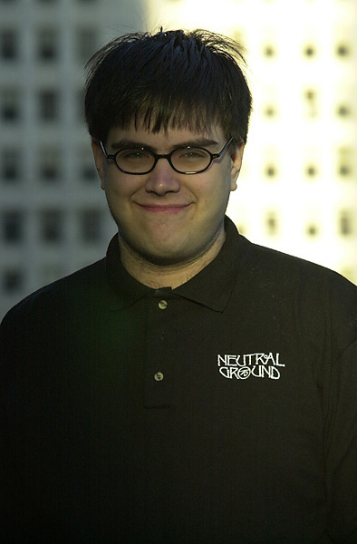
Zvi Mowshowitz - Zvi has more than reinforced his reputation as one of the best Constructed players this year, and with his infamous work ethic having kicked in once again, he seems poised to make a run at the World Championship. Zvi has had some difficulties in Limited Pro Tours this year, but he'll be as ready as anyone for the two-thirds of the rounds that take place in Constructed He's ensured this by surrounding himself with the strongest team of players going into Worlds, with his Team Godzilla including Kai Budde, Scott Johns, Benedikt Klauser, John Ormerod, Patrick Mello and a host of others.
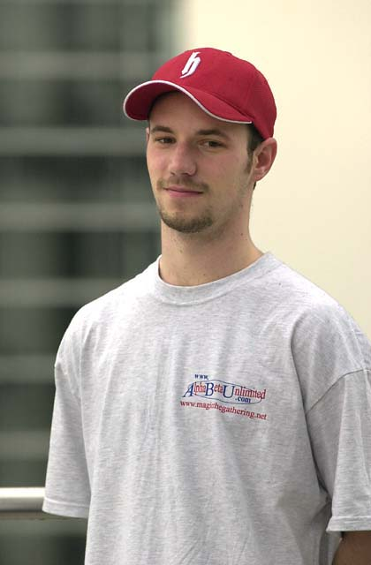
Ryan Fuller - The flipside of Zvi, Fuller has been travelling to GPs around the globe all year while playing Magic full time. Ryan probably tests a lot more than he claims, but he thrives on his considerable talent, which carried him to a 14-0 record in the Swiss portion of PT Tokyo this year. Fuller's best performances have come in Constructed this year, with his Tokyo performance joined by GP wins at Prague, Moscow and Yokohama and a win in the Tokyo Masters. Preparing to take a step back in the form of a move back to Canada from Amsterdam, you'd have to think he's exited at the prospect of excelling in his home country.
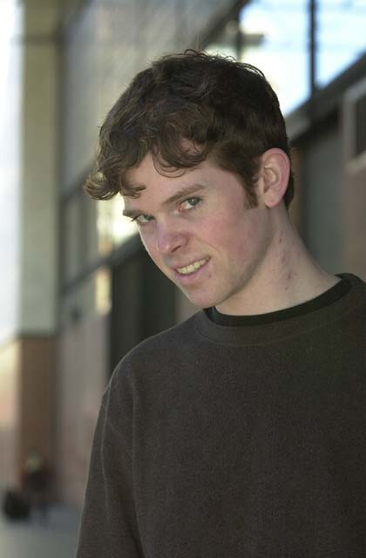
Dan Clegg - It seems really strange to call Dan the hottest player on the Tour, but it's really true. Dan has been on the Tour for a while, but he never got a taste of the Day 3 spotlight until the first Pro Tour of the season, New York, where his team, Rolled Up Aces made it to the semifinals. Dan followed this up with his third-place finish in Barcelona. Despite these accomplishments, it has been his recent Grand Prix finishes that have really impressed, with his win in Turin and Top 8 finishes in Dallas, Detroit and Columbus showing an increased consistency that has come with an increased rate of play from a player known for his lack of speed. A Worlds win would be highly surprising, but a strong finish would not.
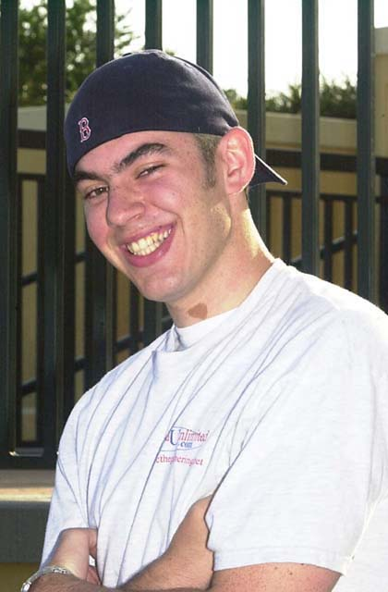
Chris Benafel - The cocky westerner showed up on the Tour a year and a half ago with his second-place finish in Los Angeles and hasn't let up one iota since. Chris made last year's U.S. National Team which won Worlds, won two team GPs, one individual one and came runner up in another. Throw in another Top 8 performance at U.S. Nationals and you have a player who has shown remarkable poise considering his lack of experience. Chris specializes more in Limited play, but his Top 8 finish this year in Tokyo shows that he's more than capable in Constructed, so a strong finish following his twelfth place finish a year ago should be expected.
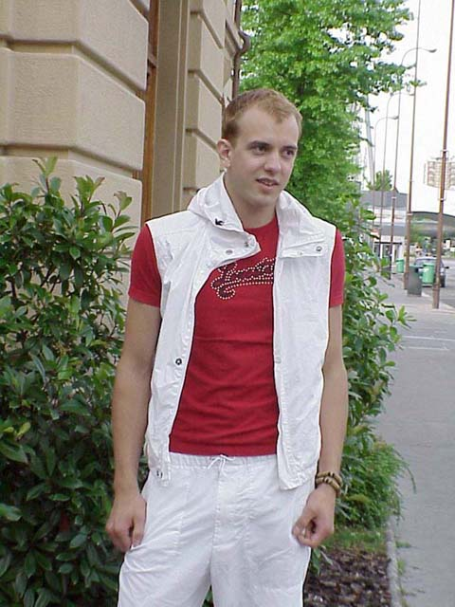
Eivind Nitter - A year ago, Eivind was a scatterbrained, emotional, inexperienced, occasional participant on PT and took his lumps for it, but now, with newfound maturity, he has newfound success. Eivind's Team Outland came in fifth at PT-NY this year and he followed it up with a number of strong showings at PTs before leaping into the big time with his win at European Championships. Playing Counterrebel, Eivind cruised to victory in a tournament requiring strength in both Limited and Constructed, against an international field of Pro-level competitors. If he did it once, he could do it again.
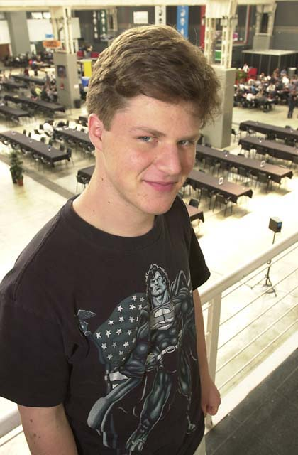
Ben Rubin - Ben's had a horrible Pro Tour season, nearly falling off the gravy train, but in between dismal failures, he's managed to accomplish the amazing. Playing against only the Tour's best, Ben has dominated the Masters Series, going an amazing 13-1 en route to winning two of three individual tournaments, one apiece in Limited and Constructed. Amazingly mature for his age, the San Francisco native needs to get his Swiss game in gear, but he's definitely capable of repeating his Top 8 performance from three years ago
Be sure to tune in to sideboard.com next week for coverage of the event, and to tomorrow's Wise Words for a look at how the Team competition at Worlds is shaping up.

